**K Means:**

S = read.csv(“DataSet.txt”, header=TRUE)

tail(s)

s$Level=NULL

tail(s)

pri<-kmeans(s,2)

plot(steps[c(“s”)],col=pri$cluster)

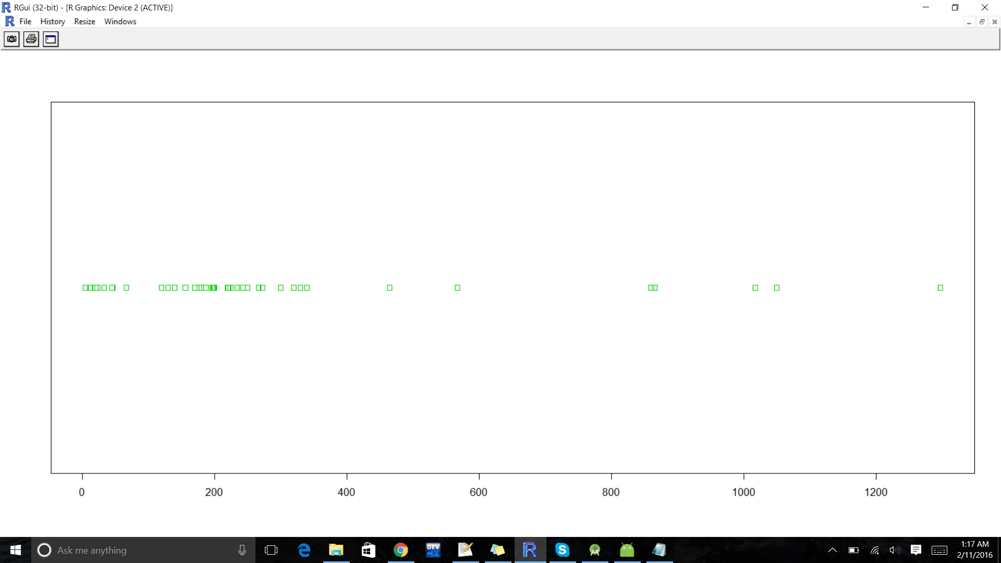

**Heirarchical Clustering**

head(s)

s$Level = NULL

head(s)

hc.priyaCom=hclust(dist(s), method=”complete”)

plot(hc.priyaCom,main =”HeirarchicalClustering(priyaCom)”, cex=1.2)

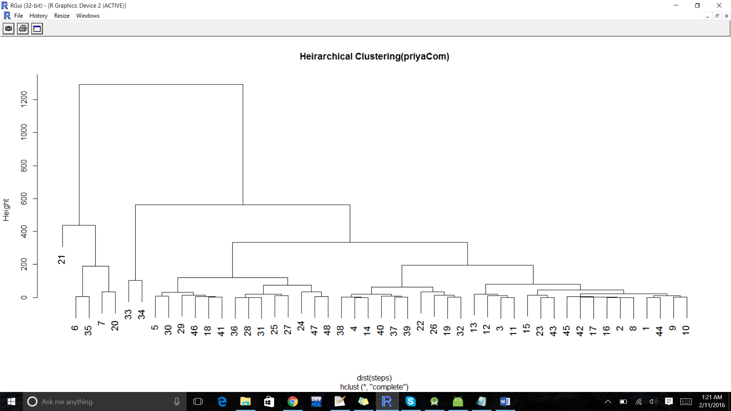

**K Medoids**

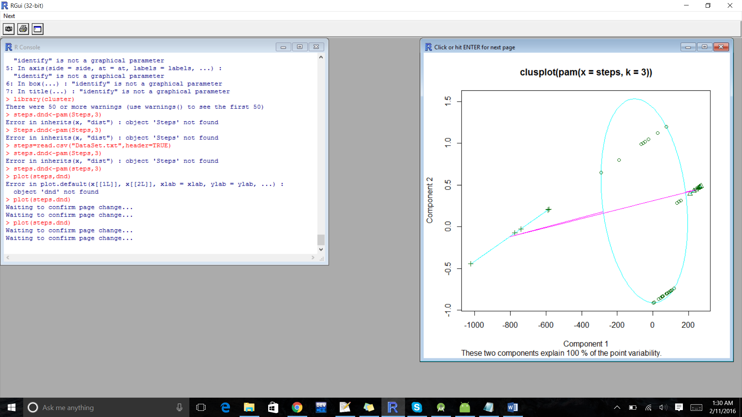

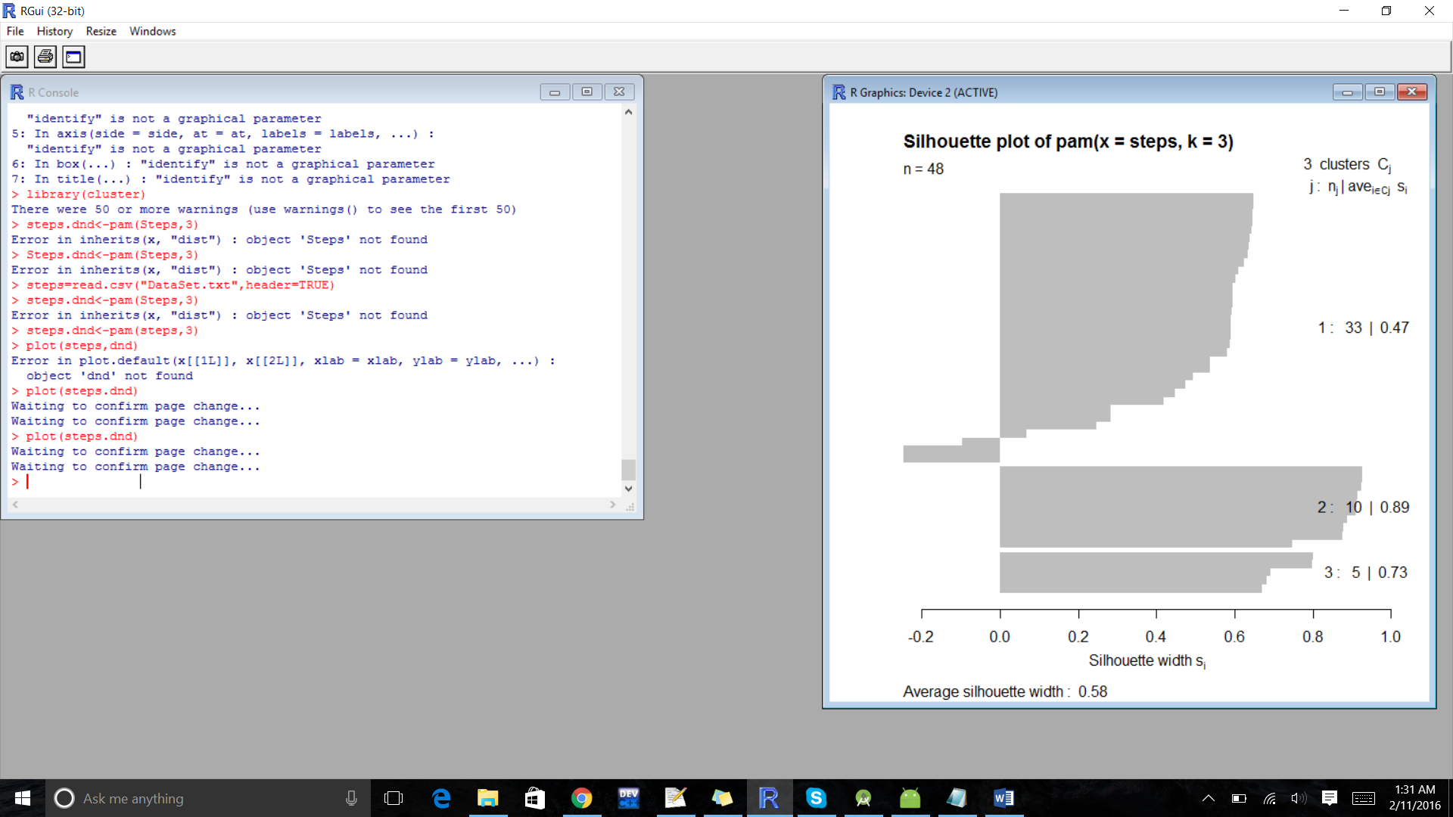

**Expectation Maximization:**

